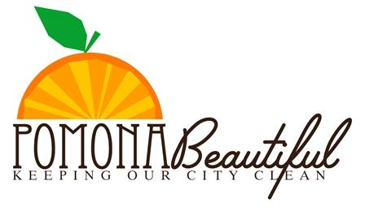

Adopt-A-Street • Park
Application/Renewal Form
Instructions: Send Completed form to:
Keep Pomona Clean & Beautiful • 505 Garey Ave, Pomona, CA • 91766
Phone – (909)285-9376 • Email – pomonabeautiful@gmail.com
Applicant Information
Organization/Business Name:

Main Contact:

Street Address: | City: | State: | Zip Code:
Phone: | Email:
Please Check Desired Type:
Volunteer Based: □ Adopt-A-Street □ Adopt-A-Park
Number of Volunteers:
Age Range of Participants:
Location of adopted area or location of renewal:
Name of Organization/Business as it is to appear on sign: Please limit to 20 characters including spaces. No phone numbers, logos, or websites.

Acknowledgement:
I hereby state that the information above is correct to the best of my knowledge and agree to all terms and conditions stated within the guidelines packet.
Signature: | Date:
Staff Use Only:
Application Received: __/__/__ Received By: ________________

Approved By: ___________________

