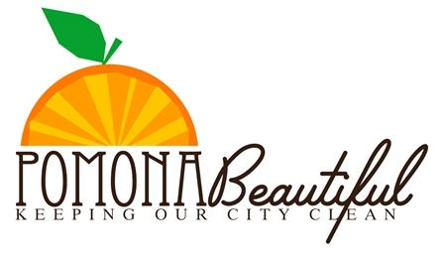

Adopt-A-Neighborhood• Report Form

IMPORTANT – record your project statistics by filling out this form and returning it to Pomona Beautiful
Pomona Beautiful asks each Adopted Street, or Park to be maintained five times a year and submit a completed Report Form for each cleanup.
Date of Cleanup: _______________ Organization Name: ______________________________________
Your Adopted Street, Park:
_______________________________ from: ___________________________ to: _________________
EXAMPLE: Main Street from: First Street to: Second Street
Did you borrow tools from Pomona Beautiful? NO YES Pickup date _________
# Volunteers _________
# Tumbleweeds removed _________
# Hours each volunteer worked _________
# Palm fronds removed _________
# Trash bags collected _________
# Green waste bags _________
# Lots cleaned _________
# Illegal Signs/Poles/Etc. eradicated _________
# Alleys cleaned _________
# Graffiti Tags removed _________
# Side streets _________
# Storm Drains cleaned _________

Please list any bulky items collected and the amount (such as; furniture, appliances, tires, etc.)*: _________________________________________________________________________________________________ _________________________________________________________________________________________________ *Review your Adopt-A-Street Guidelines for information on how to remove these items from your street
Notes/requests/comments are sent to Pomona Beautiful Adopt-A-Neighborhood program, Project Coordinator via email: pomonabeautiful@gmail.com _________________________________________________________________________________________________ _________________________________________________________________________________________________

Primary Contact:
Name: ____________________________________________________________________________
Phone: __________________________ Email: ___________________________________________

